**Coding Challenge-1**

**Question:**

**Create Azure Devops Environment and configuring Azure Devops Git Repository, configure on your local git to implement this upload few test files on same.**

**Solution**

**Creating Azure Devops Environment by creating a new project**

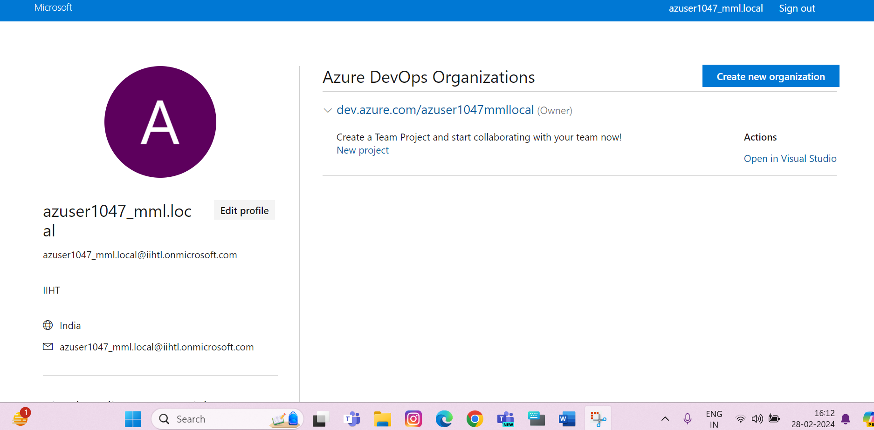

**New Project by the name of CodingChallenge created:**

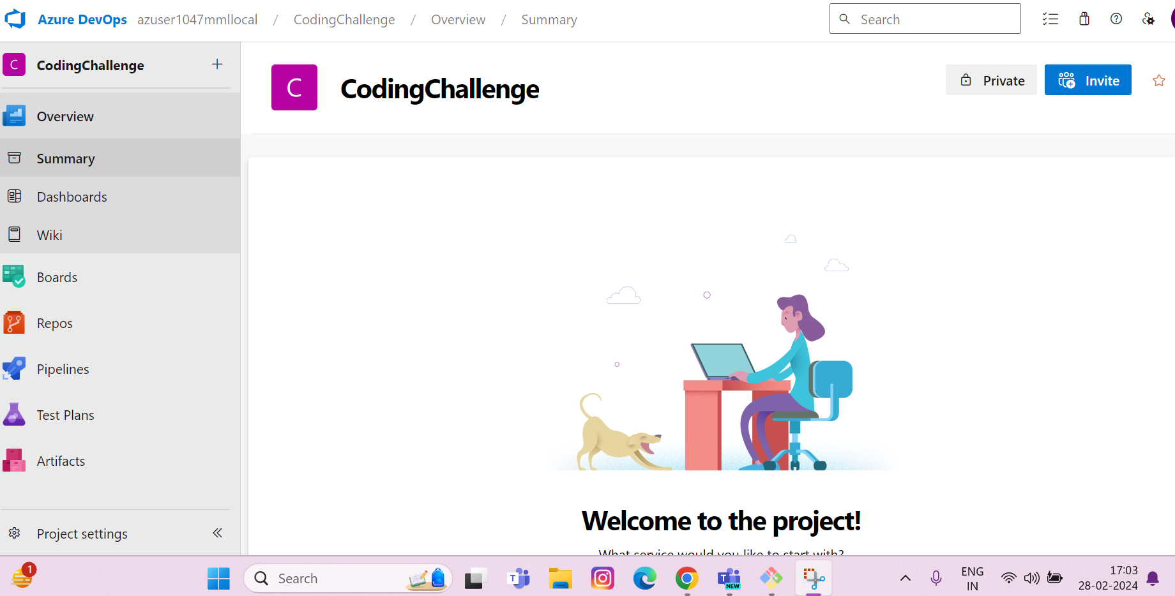

**Navigating to the Repos Section to copy the url for further process**

**GIT BASH PROCESS**

1. **First go to the folder on your local system where you want to create a new directory:**
2. **Here I have went to downloads and created a directory called “mydirectory”**
3. **Next we go inside that directory and start the cloning process**
4. **Using “git init” command and “git clone”**
5. **With git clone we paste the url that we have copied from the azure devops repository**

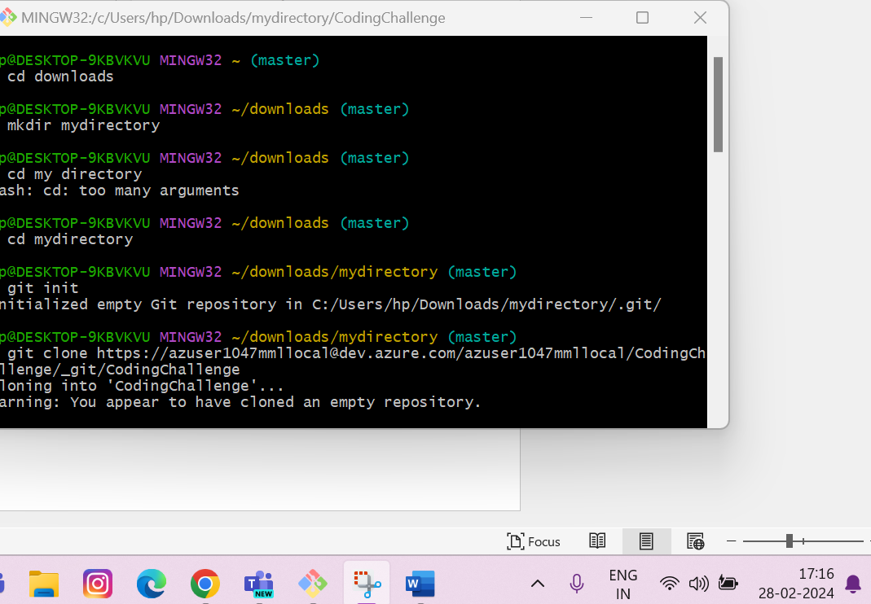

1. **After this a directory by the name of CodingChallenge is created inside mydirectory and we then go into that directory by using cd CodingChallenge:**

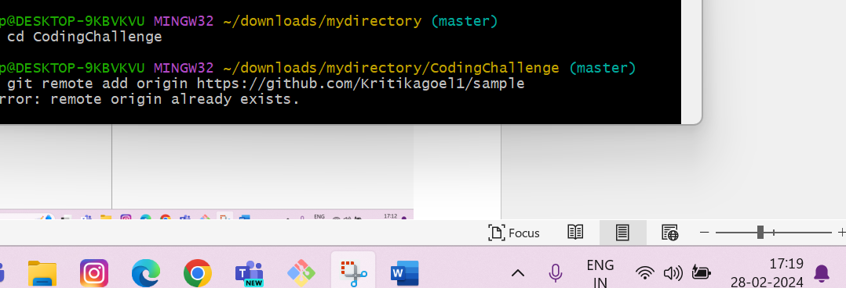

1. **Then I have moved an “EmployeeDetails.csv” file from desktop to the CodingChallenge directory**
2. **And added and committed the changes through commands:**

* **“git add .”**
* **“git commit -m “EmployeeDetails.csv”**

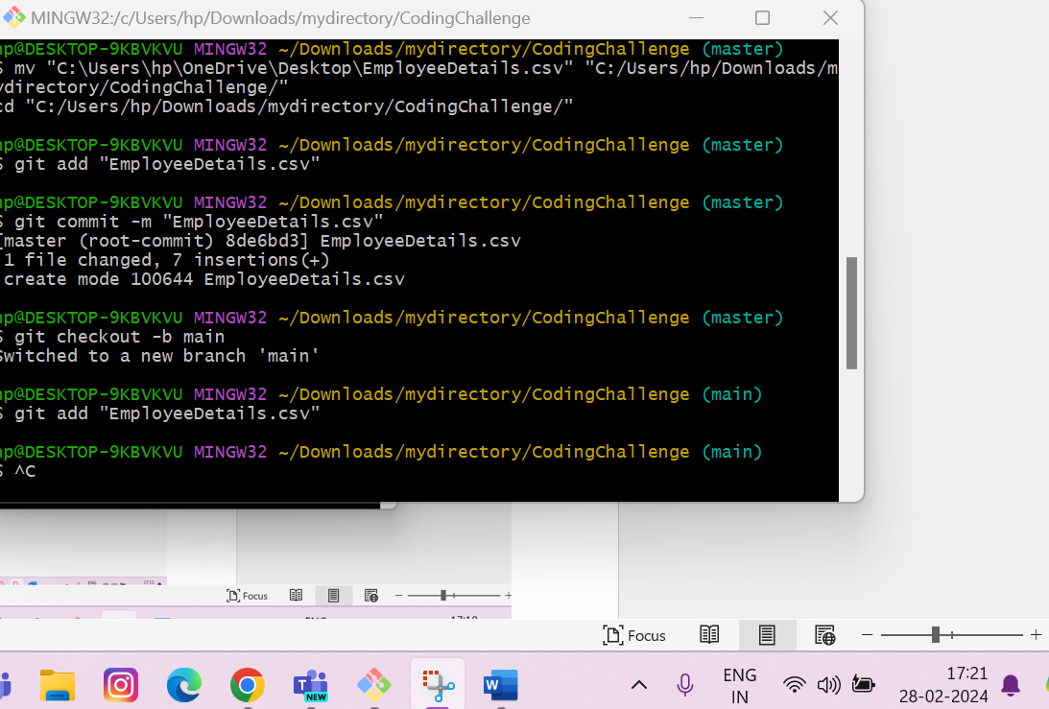

1. **Then using git push -u origin main I have pushed the directory to azure devops repository:**

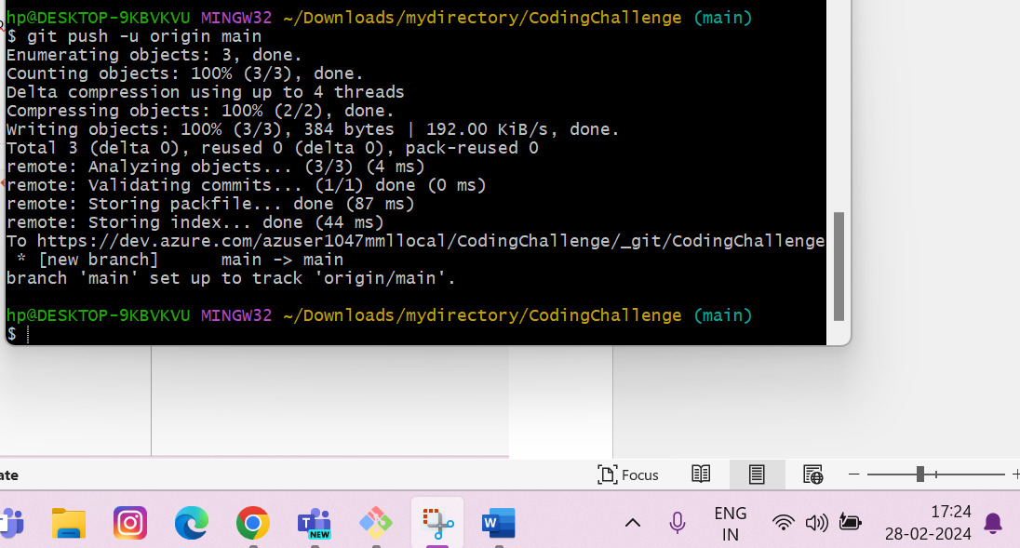

**Final output:File has been copied to the DEVOPS repository**

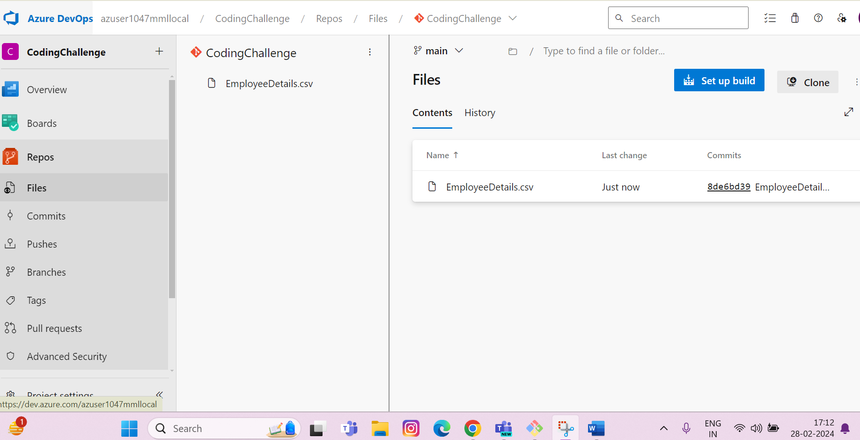

**History of all the commands I ran:**

